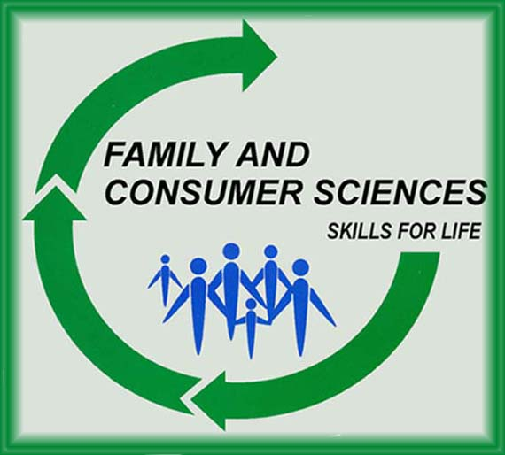
Skills for Life In the 21st Century

Course Outline: 7th Grade Level Home and Career Skills
7th Grade:  Modules of Curriculum  Module I: Personal Development: Stages of Human Development, What Makes Me, Me? How Do I Relate To Others?,  Module II: The Process Skills: Problem Solving & decision Making, Study Skills, Types of Decisions, Goals and Goal Settings, Resources  Module III: Personal and Family Resource management: Clothing and Textiles, Fashion and Personal Choices, Money Management, Consumer Skills  Module IV: Nutrition and Wellness: Food Guide Pyramid, Personal Food Choice, Eating Disorders, Measuring/Equivalents, Food Preparation and Kitchen Skills | Expectation of Students In Class:  - To Follow School & Classroom Procedures At All Times  - To Arrive to Class Prepared  - To Demonstrate 100% Effort In Class  - To Contribute To A Positive Environment In The Classroom  - To Practice The Use Of Supplies & Equipment With Safety In The Classroom  - To Demonstrate Proper Etiquette  - To Show Respect To Peers, Teachers, & Other Guests In The Classroom  - To Understand The Food Lab Safety Contract & Have It Signed By A Parent/Guardian  - Student Are Responsible For Their Own Class Binder, handouts, and Notes

Grade Based On:
Classwork: 40% (In-Class Handouts)
Exams/Projects: 40%
Classroom Participation: 20% (Effort, Attitude)

