C3 - 15 Point Local Assessment Scale Table (with value-added)
Grades K-12, based on state exams (Regents and 3-8 NYS assessments)

Note: The point values and ranges on the HEDI point scale (from zero to 15) are determined by NYSED regulations. Numbers below represent the difference (Δ) from the NYS average in state assessment proficiency percentage (3 or better) for the entity (school or district).

 | HEDI Points | Difference (Δ) from the State Average | Range of Difference (Δ) from the State Average
  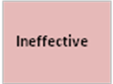 | 0 | 0% | <0% | to | 0%
 | 1 | 1% | 1% | to | 1%
 | 2 | 2% | 2% | to | 2%
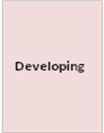 | 3 | 3% | 3% | to | 4%
 | 4 | 5% | 5% | to | 5%
 | 5 | 6% | 6% | to | 6%
 | 6 | 7% | 7% | to | 7%
 | 7 | 8% | 8% | to | 8%
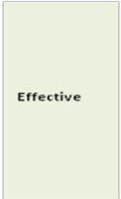 | 8 | 9% | 9% | to | 12%
 | 9 | 13% | 13% | to | 16%
 | 10 | 17% | 17% | to | 19%
 | 11 | 20% | 20% | to | 24%
 | 12 | 25% | 25% | to | 29%
 | 13 | 30% | 30% | to | 34%
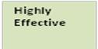 | 14 | 35% | 35% | to | 44%
 | 15 | 45% | 45% | to | >45%

Δ = [POB (school) – State Average]

Notes:
All grades will use a school-wide comparison.
ELA and Math averages will be mathematically averaged to arrive at one numeric score.
All rounding will follow commonly accepted mathematical rules for rounding.

